**LOGBOOK 1**

**Exercise 1**

**Following the instructions on the separate handout, create the script below and save it as wk1ex1.php, then run it through the browser.**

**<?php phpinfo(); ?>**

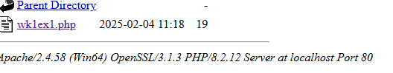

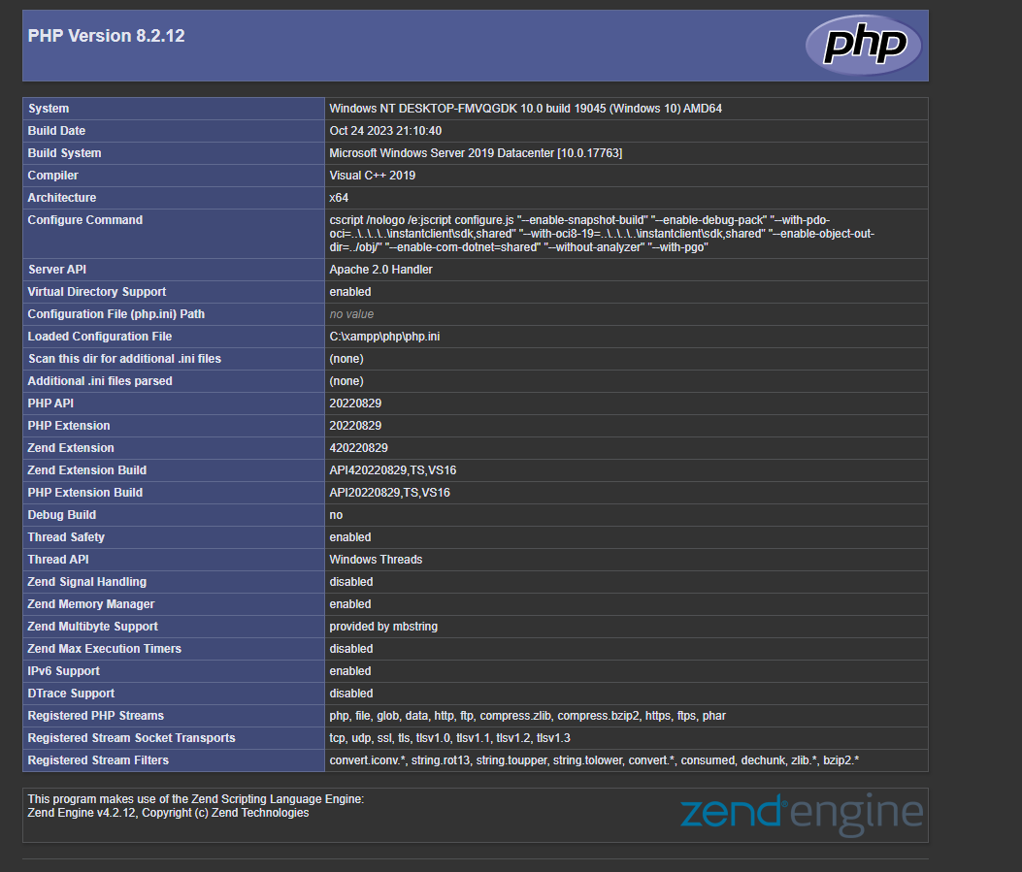

**Exercise 2**

**Save the following script as wk1ex2.php and then run it.**

**<?php echo $_SERVER["HTTP_USER_AGENT"]; ?>**

**Try passing the following arguments**

* **“SERVER_NAME”**
* **“SERVER_PROTOCOL”**

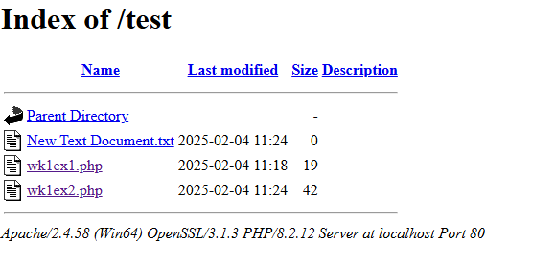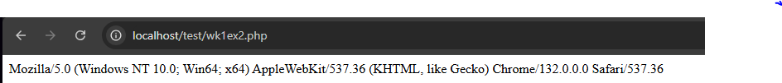

**Server_name**

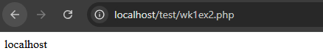

**Server_protocol**

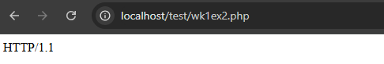

## **Exercise 3**

**The next script will print “Blimmy it worked !” on the screen.**

**Enter the script below into your editor and save it as wk1ex3.php**

|  |  |
| --- | --- |
|  | | **<html>**  **<body>**  **<?php**  **echo “Blimmy it worked !”;**  **?>**  **</body>**  **</html>** | | --- | |

**The php code is enclosed by the <?php start tag and the ?> end tag and the echo command displays the text between the double quotation marks.**

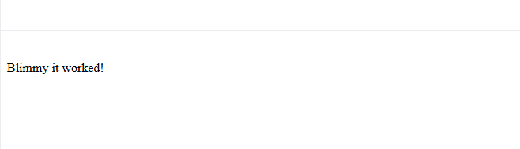

## **Exercise 4**

**Our next exercise will display the current date.**

**Name the file wk1ex4.php**

|  |  |
| --- | --- |
|  | | **<html>**  **<body>**  **<?php**  **echo gmdate(“M d Y”);**  **?>**  **</body>**  **</html>** | | --- | |

**The function gmdate() returns the current Greenwich Mean Time date based on the format specified by the string that is passed as an argument.**

***Try the following formats***

**· *“D”***

**· *“d m Y”***

**· *“z”***

***What does the last argument represent ?***

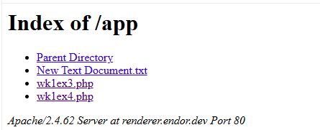

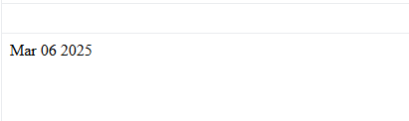

***“D” Format.***

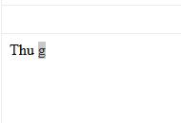

***“D M Y” format***

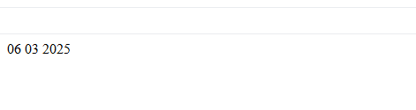

***“Z” format***

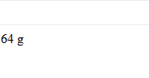

**Exercise 5**

**We can introduce variables into our scripts without prior declaration.**

**Save the following script as wk1ex5.php and display it through the browser.**

|  |  |
| --- | --- |
|  | | **<html>**  **<body>**  **<?php**  **$myfavouritemodule = “Internet Systems Development”;**  **echo $myfavouritemodule;**  **?>**  **</body>**  **</html>** | | --- | |

**Within php all variables begin with a $. Php is case sensitive so the variable $age is not the same variable as $AGE or $Age.**

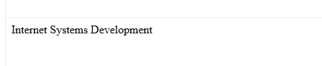

**Exercise 6.**

**Exercise 5 assigned a string ( enclosed in double quotation marks ) to a variable, as with other languages php provides a means of concatenation ( adding one string to another ) using the full stop character “.”**

**Save the following script as wk1ex6.php**

| | **<html>**  **<body>**  **<?php**  **$firstname = “Richard”;**  **$lastname = “Mather”;**  **$name = $firstname . $lastname;**  **echo $name;**  **?>**  **</body>**  **</html>** | | --- | |
| --- | --- |

**The problem with the above exercise is that there is no space between the first and last name.**

***Introduce a new variable $space and assign it a value of “ “. Include the new variable in the concatenates statement and run the script.***



***Exercise 7***

***In addition to the string type we can introduce integer and double types into our scripts and carry out calculations using the following operators***

***+ addition***

***\* multiplication***

***- subtraction***

***/ division***

***% modulus***

***Save the following script as wk1ex7.php***

| | ***<html>***  ***<body>***  ***<?php***  ***$hourlyrate = 5.75;***  ***$hoursperweek = 40;***  ***$gross = $hourlyrate * $hoursperweek;***  ***echo $gross;***  ***?>***  ***</body>***  ***</html>*** | | --- | |
| --- | --- |

***The above script calculates my gross wage. Modify it so that it calculates my net wage ( after tax ) based on a tax rate of 22%.***

